Chapter 1, Problem 12.

If the current flowing through an element is given by
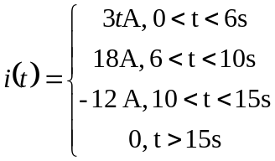
Plot the charge stored in the element over 0 < t < 20s.

